**CIS-481: Introduction to Information Security**

**InfoSec Chapter Exercise #1**

**Team: 7**

**Names: Jackson Dillingham, Matthew Jackson, Tabor Payne, Hilton Siaffa, and Emily Wantland**

**Logistics**

1. Get together with other students on your assigned team in person and virtually.
2. Discuss and complete this assignment in a collaborative manner. Don’t just assign different problems to each teammate as that defeats the purpose of team-based learning.
3. Choose a scribe to prepare a final document to submit via Blackboard for grading, changing the file name provided to denote the number of your assigned **Team**.

**Problem 1**

The CIA triad presents three essential characteristics of information that must be protected. However, most agree that these three characteristics are not the only ones that need to be protected. Other characteristics include authenticity, accuracy, possession, timeliness and utility.   
If you were tasked with expanding it into an information security *rectangle* instead by adding a single additional characteristic of information, which would you choose and why? *(8 points)*

* We would choose the utility characteristic because we believe information should have a purpose. The organization has to assign value to the data for it to be worth something. Without that value, the data will be difficult to interpret. Utility adds meaning, data only has value when it can serve a purpose and without meaning it is not useful.

**Problem 2**

In 1991, John McCumber proposed a model for Information Security that uses a 3-D cube, as below. Describe each of the three dimensions of the McCumber Cube and comment on the interaction of the three specific sub-components in one of the 27 cells within the Cube. *(9 points)*

* Information Characteristics: Describes the CIA triad, these characteristics were at the time considered the most important information characteristics. Many have since been added as security has become more prevalent. The triad is used to display the objectives of a information system’s security program.
* Security Countermeasures: These describe the actions users must take when working with information systems. It describes the interactions we have with information systems.
* Information States: Information is always in three states depending on how the user is interacting with it. These states describe what is currently digitally happening to the data.
* Policy is how practices involving the storage and transmission of data are created. It provides the foundation for administrative controls and helps foresee risks. Data in transit between information systems must be confidential. If sensitive information is passed around, unauthorized individuals could access the resources. Therefor, it is important there are policies surrounding the transfer of confidential information.

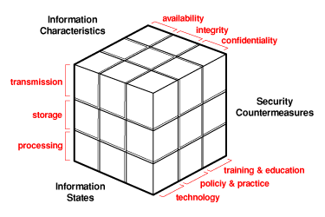

**Problem 3**

How can the practice of information security be described as both an art and a science? How does security as a social science influence its practice? *(8 points)*

* Information security can be described as an art because there are no clear rules to achieve a secure state. There is no complete manual to follow when implementing a solution. It is a science because it is testable. You can measure performance levels and employ different conditions for different results. When hardware and software interact, they can create direct malfunctions.
* Information security is primarily concerned with individuals, therefor social science influences security practices. People’s behavior must be examined in order to reduce the risk levels and maintain a more secure system. The people who interact the system should be trained so they understand that they will be held accountable for how they interact with it.